**College Event Management System**

**CHAPTER 1**

**INTRODUCTION**

* 1. **Overview of College Event Management System**

The College Event Management System Project is a web-based application project designed to streamline the organization and management of college events. The main goal of this project is to provide college administrators, event coordinators, and participants with an efficient platform to manage and participate in college events online. The login section will have three login facilities for the Administrator, Event Coordinator, and Participant. The application features a simple and pleasant user interface, leveraging the Bootstrap Framework v4, along with user-friendly functionalities.

The Administrator plays a crucial role in overseeing and managing the system. This encompasses various tasks, including adding new events, editing existing ones, and overseeing overall event activity. When creating new events, the Administrator collects pertinent information from coordinators and inputs it into the system to generate event profiles. Additionally, the Administrator is empowered to modify event details, such as schedules, venues, or participant information, as needed. Monitoring event activity is also within the Administrator's purview. Furthermore, the Administrator communicates with coordinators and participants, providing feedback and guidance as necessary. Whether addressing event-related issues or disseminating important updates, the Administrator ensures a smooth and efficient event management experience.

The Event Coordinator, upon logging in through a secure platform provided by the college, can manage specific events. Coordinators can view event details, which include a comprehensive record of event-related activities and logistics. This includes information such as dates, descriptions, and the status of each task related to the event. The coordinator can also track participant registration, manage schedules, and handle any logistical issues that arise. This information allows Coordinators to ensure that events run smoothly, monitor participant engagement, and identify any areas needing attention.

The Participants can log into the system to view upcoming events, register for events, and receive updates. They can access event schedules, venue details, and any pertinent information regarding their participation. This platform provides participants with the ability to track their event activities, receive notifications about changes or updates, and stay informed about college events efficiently.

The Event Coordinators assist participants and other stakeholders by encoding event registration and management details into the college's event management system. For event registrations, they enter details like the participant's name, student ID, event name, and registration date. For event updates or cancellations, they input similar information along with any pertinent details regarding the changes. This process ensures that event records are accurately updated. The coordinator’s responsibilities include handling event registrations, managing event logistics, and ensuring participants receive necessary information. Throughout these processes, Coordinators follow strict protocols to maintain the integrity and smooth execution of events.

Online event management allows users to access the system and manage various event-related activities over the internet. Through secure websites or mobile apps provided by the college, users can view event schedules, register for events, check event updates, receive notifications, and communicate with event coordinators. Online event management offers convenience, 24/7 accessibility, and often enhanced security features such as two-factor authentication to protect users' sensitive information.

In addition to the core functionalities of managing events, conducting registrations, and ensuring security, the online event management system also focuses on providing a seamless and user-friendly experience to participants and coordinators. It prioritizes robust security measures, including encryption standards and secure login procedures, to safeguard sensitive user data and activities.

Moreover, the system emphasizes multi-platform accessibility, enabling users to access the event management system and perform activities across various devices such as desktop computers, tablets, and smartphones. To enhance user awareness and engagement, the system offers notifications and alerts, empowering users to stay informed about event activities and updates.

Responsive support channels, including online chat support and dedicated helplines, ensure prompt assistance and resolution of any user queries or issues. Furthermore, the system may integrate with external platforms and services to provide users with a comprehensive event management experience. Compliance with institutional standards and continuous improvement through updates and feature enhancements underscore the system's commitment to maintaining legality, security, and user satisfaction in the evolving landscape of college event management.

**1.2 OBJECTIVES**

The objectives of the College Event Management System encompass enhancing participant experience, improving event coordination efficiency, and ensuring the security and reliability of event-related services. Specific objectives include:

* **Event Scheduling and Management:** Efficiently schedule and manage events, ensuring accurate tracking and reporting of event details such as dates, venues, and participants.
* **Participant Information Retrieval:** Provide users with quick and secure access to their event information, facilitating seamless registration, inquiries, and participation.
* **Registration Processing:** Streamline registration processing for timely and accurate enrolment in events, enhancing participant satisfaction and operational efficiency.
* **Event History Display:** Display detailed event history to users, enabling them to track and review past events for better engagement and transparency.
* **Feedback Mechanism:** Allow participants and coordinators to provide feedback, enhancing user engagement and enabling the college to gather valuable insights for improving event services.

**1.3 About DBMS**

A database management system (DBMS) is system software designed for creating and managing databases. A DBMS allows end users to create, protect, read, update, and delete data in a database. As the most prevalent type of data management platform, the DBMS acts as an interface between databases and users or application programs, ensuring that data is consistently organized and remains easily accessible.

A DBMS manages the data through several key components:

* **Data Management**: Ensures data can be accessed, locked, and modified.
* **Database Engine**: Facilitates access to the data while maintaining data integrity.
* **Database Schema**: Defines the logical structure of the database.

These foundational elements provide concurrency, security, data integrity, and uniform data administration procedures.

Additionally, a DBMS supports many typical database administration tasks, including change management, performance monitoring and tuning, security, and backup and recovery. Most DBMSs are also responsible for automated rollbacks and restarts, as well as logging and auditing of activity in databases and the applications that access them.

**1.4 About RDBMS**

A Relational Database Management System (RDBMS) is a type of DBMS that organizes data in predefined relationships where data is stored in one or more tables (or "relations") consisting of columns and rows. This structure makes it easy to see and understand how different data structures relate to each other. Relationships are logical connections between different tables, established based on interactions among these tables.

The most basic RDBMS functions include create, read, update, and delete operations, collectively known as CRUD. These operations form the foundation of a well-organized system that promotes consistent treatment of data.

An RDBMS typically provides:

* **Data Dictionaries**: Repositories that store metadata and definitions of data structures.
* **Metadata Collections**: Useful tools for data handling and supporting well-defined data structures and relationships.

These features enable users to efficiently manage and manipulate relational databases, ensuring data consistency and integrity across various applications.

**CHAPTER 2**

**System Requirements Specification**

**2.1 Software Requirements**

* **XAMPP**
* **Operating System**: Windows 10 and above / macOS / Linux

**2.2 Hardware Requirements**

* **Memory**: Minimum of 1GB RAM
* **Storage**: Minimum 3GB for Database usage

**2.3 Technologies Used**

* **PHP**
* **MySQL Database**
* **HTML**
* **CSS**

**2.4 About Tool Used**

**2.4.1 XAMPP**

XAMPP is an abbreviation where X stands for Cross-Platform, A stands for Apache, M stands for MySQL, and the Ps stand for PHP and Perl, respectively. It is an open-source package of web solutions that includes an Apache distribution for many servers and command-line executables along with modules such as the Apache server, MariaDB, PHP, and Perl. XAMPP helps a local host or server test its website and clients via computers and laptops before releasing it to the main server. This ensures that the web application functions correctly and efficiently in a controlled environment before going live.

**2.5 About Programming Language**

**2.5.1 PHP**

PHP stands for Hypertext Preprocessor. It is an open-source, interpreted, and object-oriented scripting language that is executed on the server side, making it particularly well-suited for web development. PHP is used to develop web applications that run on the server and generate dynamic web pages. Created by Rasmus Lerdorf in 1994, PHP officially entered the market in 1995.PHP code can be embedded into HTML code or used in combination with various web template systems, web content management systems, and web frameworks. Typically, PHP code is processed by a PHP interpreter, which can be implemented as a module in a web server or as a Common Gateway Interface (CGI) executable. The web server then combines the results to generate the final web page, enhancing the dynamic nature of web applications.

**CHAPTER 3**

**System Design**

**3.1 Schema Diagram**

**events**

|  |  |  |  |  |  |  |  |
| --- | --- | --- | --- | --- | --- | --- | --- |
| event_id | event_title | event_price | participates | img_link | type_id | dept | rules |

**event_info**

|  |  |  |  |
| --- | --- | --- | --- |
| event_id | date | time | location |

**event_type**

|  |  |
| --- | --- |
| type_id | type_title |

**participent**

|  |  |  |  |  |  |  |
| --- | --- | --- | --- | --- | --- | --- |
| usn | name | branch | sem | email | phone | college |

**registered**

|  |  |  |
| --- | --- | --- |
| rid | usn | event_id |

**staff_coordinator**

|  |  |  |  |
| --- | --- | --- | --- |
| stid | name | phone | event_id |

**student_coordinator**

|  |  |  |  |
| --- | --- | --- | --- |
| sid | st_name | st_phone | event_id |

**Fig - 1** Schema Diagram for the College Event Management System

**3.2 E R Diagram**

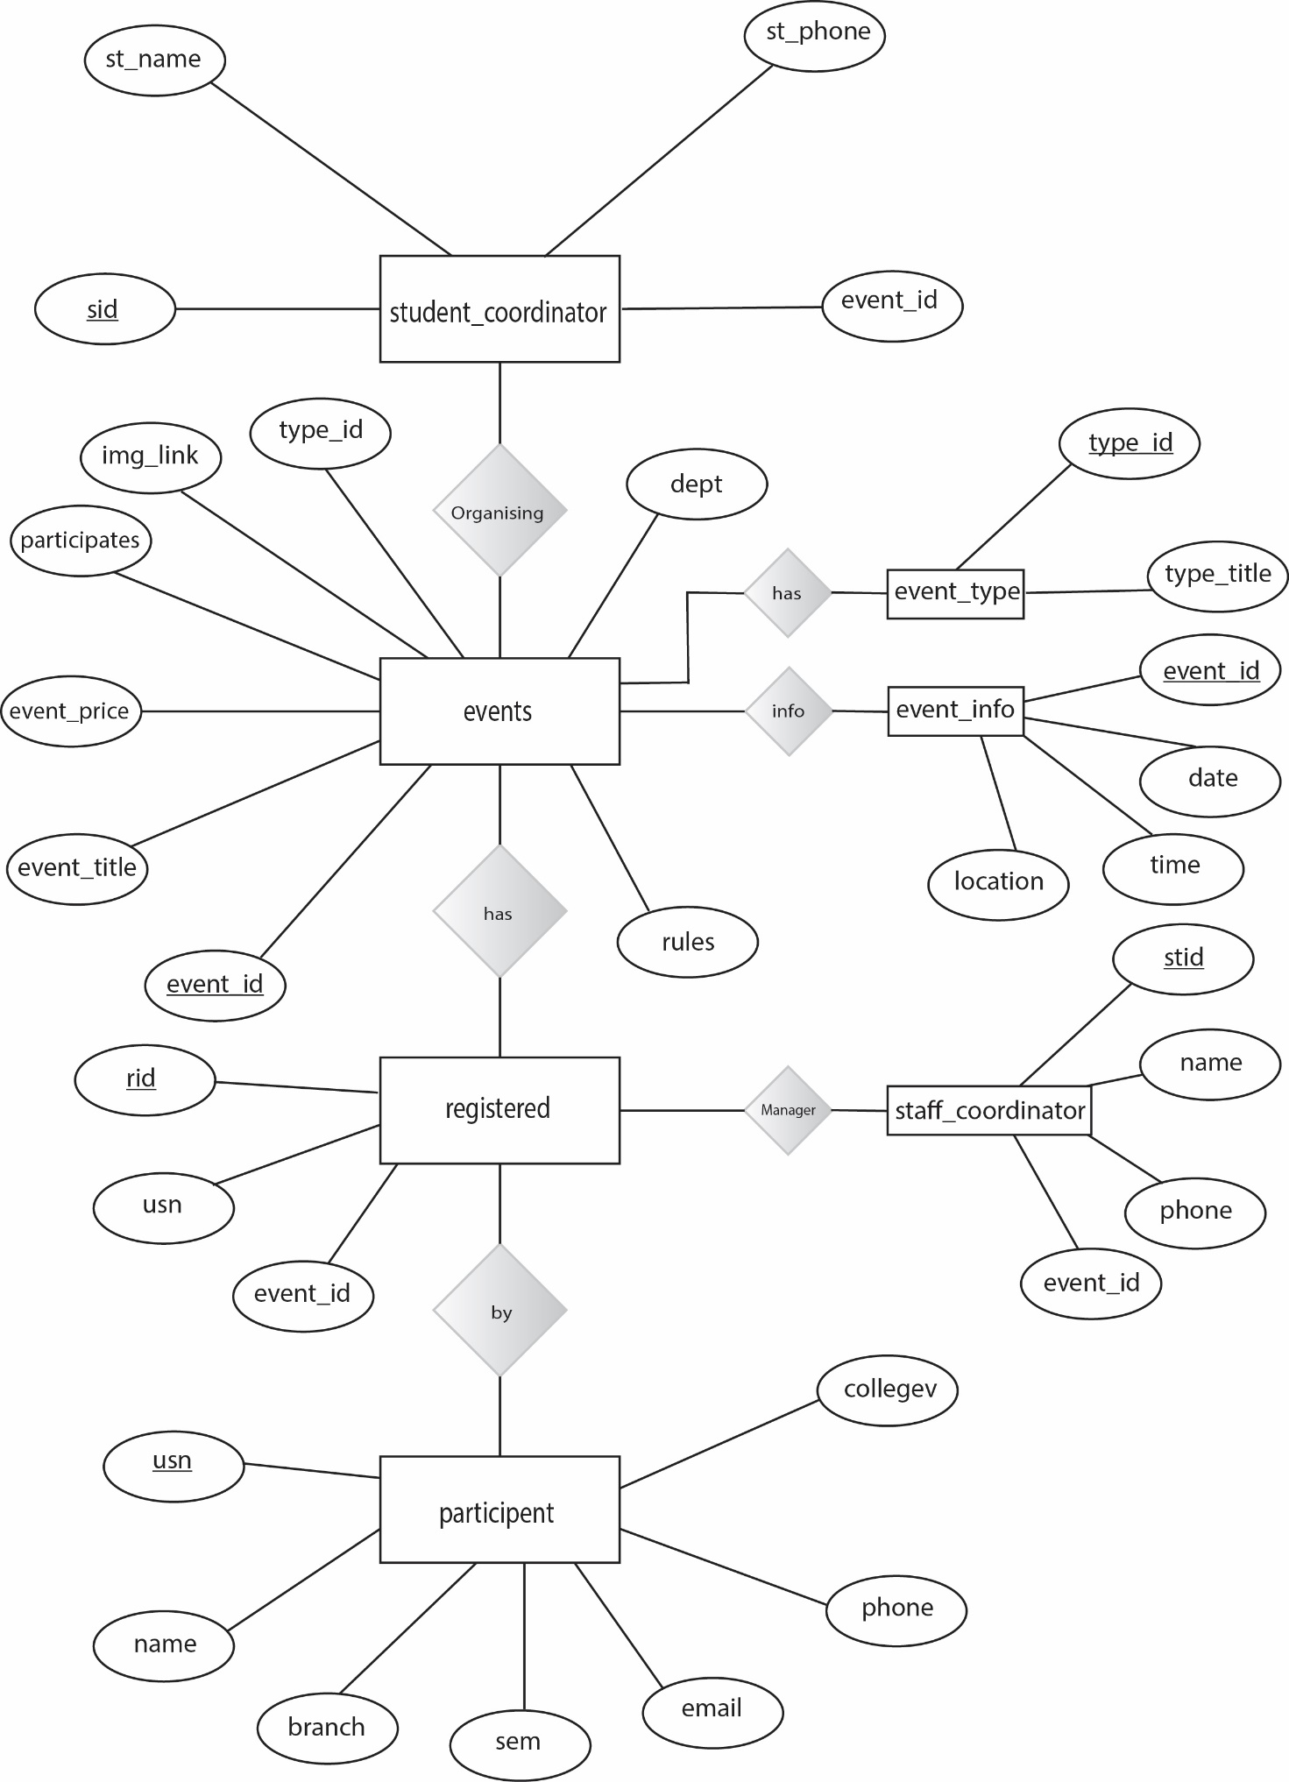

**Fig – 2** E R Diagram for the College Event Management System

**Entities and Relationships**

1. **events**
   * Attributes: event_id, event_title, event_price, participents, img_link, type_id, rules, dept
   * Primary Key: event_id
   * Relationships:
     + Many-to-One with event_type (type_id)
     + One-to-One with event_info (event_id)
     + One-to-Many with registered (event_id)
     + One-to-Many with staff_coordinator (event_id)
     + One-to-Many with student_coordinator (event_id)
2. **event_info**
   * Attributes: event_id, Date, time, location
   * Primary Key: event_id
   * Relationships:
     + One-to-One with events (event_id)
3. **event_type**
   * Attributes: type_id, type_title
   * Primary Key: type_id
   * Relationships:
     + One-to-Many with events (type_id)
4. **participent**
   * Attributes: usn, name, branch, sem, email, phone, college
   * Primary Key: usn
   * Relationships:
     + One-to-Many with registered (usn)
5. **registered**
   * Attributes: rid, usn, event_id
   * Primary Key: rid
   * Relationships:
     + Many-to-One with events (event_id)
     + Many-to-One with participent (usn)
6. **staff_coordinator**
   * Attributes: stid, name, phone, event_id
   * Primary Key: stid
   * Relationships:
     + Many-to-One with events (event_id)
7. **student_coordinator**
   * Attributes: sid, st_name, st_phone, event_id
   * Primary Key: sid
   * Relationships:
     + Many-to-One with events (event_id)

**3.3 Data Flow Details**

**• Participants** interact with the College Event Management System for event registration, feedback submissions, and updating personal information.

• The **College Event Management System** provides participants with event confirmations, schedule notifications, event updates, and feedback responses.

• **Administrators** interact with the College Event Management System for coordinator performance reviews, role adjustments, and event approval/rejection decisions.

• The **College Event Management System** provides administrators with event activity reports, participant engagement metrics, and coordinator performance metrics.

• **Event Coordinators** interact with the College Event Management System for event scheduling requests, participant inquiries, and event cancellations.

• The **College Event Management System** provides event coordinators with participant information verification, event registration confirmations, and event notifications.

**CHAPTER 4**

**System Implementation**

The College Event Management System encompasses robust software solutions that manage core event functions such as participant management, event scheduling, and coordinator interactions. These software platforms are designed to be secure, capable of handling high volumes of transactions, and ensure data integrity and confidentiality. The system incorporates digital channels and self-service options to enable participants and coordinators to access event services conveniently from anywhere at any time, allowing users to check event schedules, register for events, provide feedback, and perform other interactions remotely.

**4.1 Modules**

**4.1.1 Manager Module**

**a) Session Management**

* **Session Start**: The script begins with session_start() to initiate or resume a session. This function is crucial for managing user sessions throughout the application.
* **Session Variable Check**: It checks if the session variable is set. If the session variable is not set, it redirects the user to the login page, ensuring that only logged-in users can access the manager module functionalities.

**b) Deleting User Accounts**

* **Detecting Delete Parameter**: If the script detects a delete parameter in the URL, it indicates an attempt to delete a user account.
* **Deleting from Database**: The script attempts to delete the user account from the database table based on the provided ID.
* **Redirection After Deletion**: After successful deletion, it redirects the user back to the accounts page. This helps maintain the user flow and ensures that the user sees the updated list of accounts after deletion.

**4.1.2 Event Coordinator Module**

**a) Event Management**

* **Session Management**: Similar to the manager module, session management is crucial for ensuring that coordinators are logged in to access their functionalities.
* **Event Scheduling**: Coordinators can create, update, and delete events. This includes entering event details such as name, date, time, and location into the system.
* **Participant Management**: Coordinators can view participant lists for events they manage, check registrations, and handle cancellations.

**b) Communication with Participants**

* **Notifications**: Coordinators can send notifications to participants about event updates, schedule changes, and important announcements.
* **Feedback Collection**: Coordinators can collect and review feedback from participants to improve future events.

**4.1.3 Participant Module**

**a) Event Registration**

* **Account Creation and Login**: Participants must create an account and log in to register for events.
* **Event Browsing**: Participants can browse upcoming events and view detailed information about each event.
* **Registration**: Participants can register for events directly through the system. This includes selecting events and confirming their participation.

**b) Feedback and Inquiries**

* **Feedback Submission**: Participants can submit feedback for events they have attended. This feedback is stored in the system for review by coordinators and administrators.
* **Inquiries**: Participants can send inquiries about events, which are routed to the appropriate coordinators for response.

The implementation of these modules ensures a seamless, user-friendly experience for all users of the College Event Management System, providing a comprehensive platform for managing and participating in college events.

**CHAPTER 5**

**Snapshot and Result**

**5.1 Participant Page**

**5.1.1 Enter page**

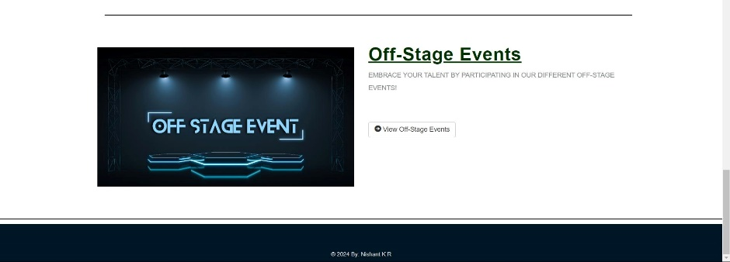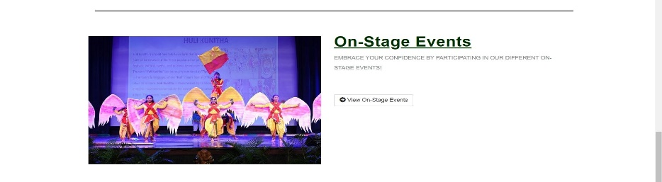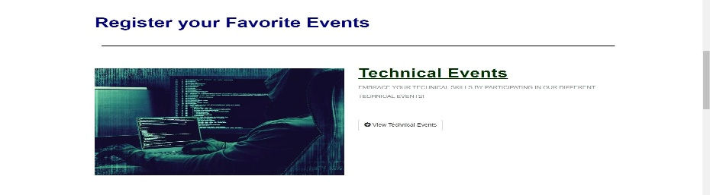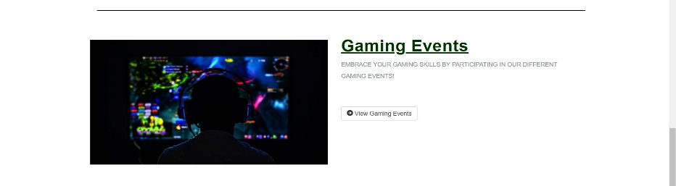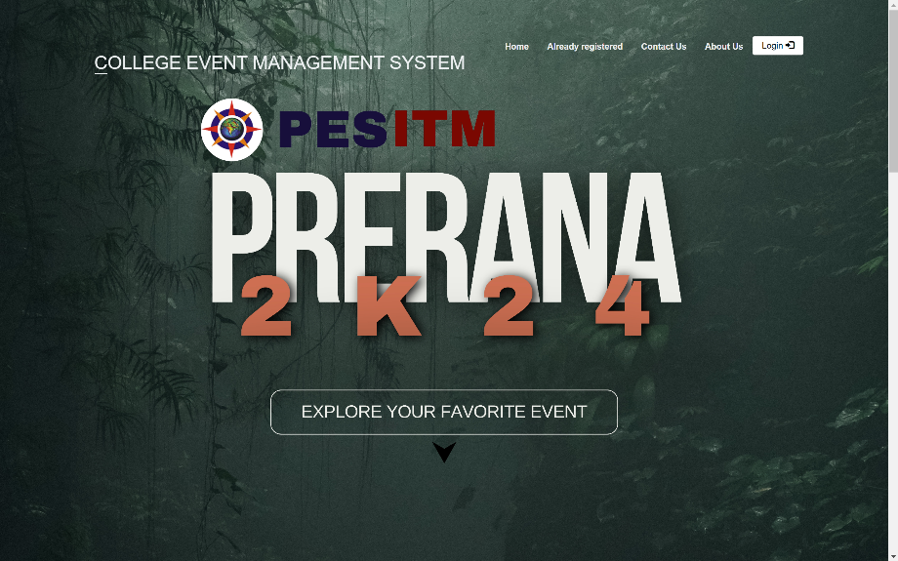

**5.1.2 Register page**

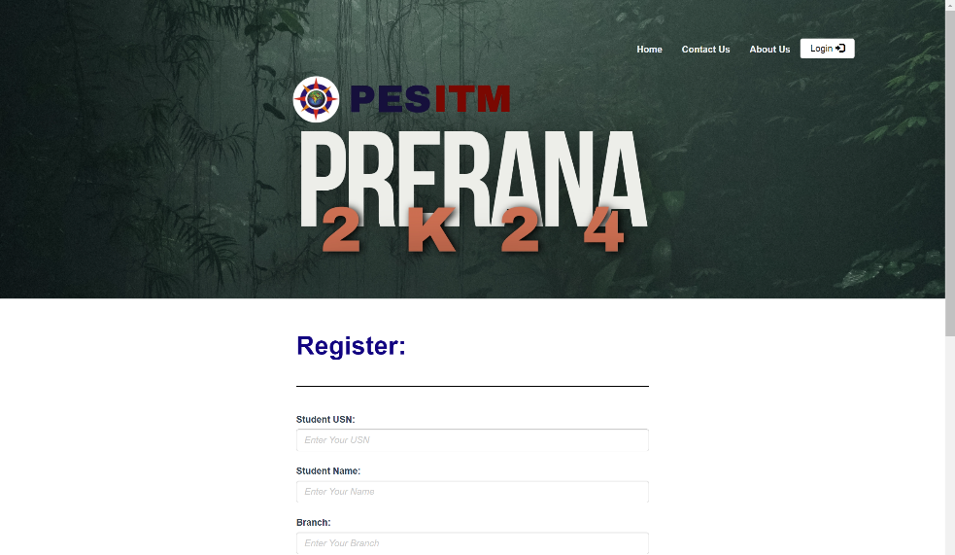

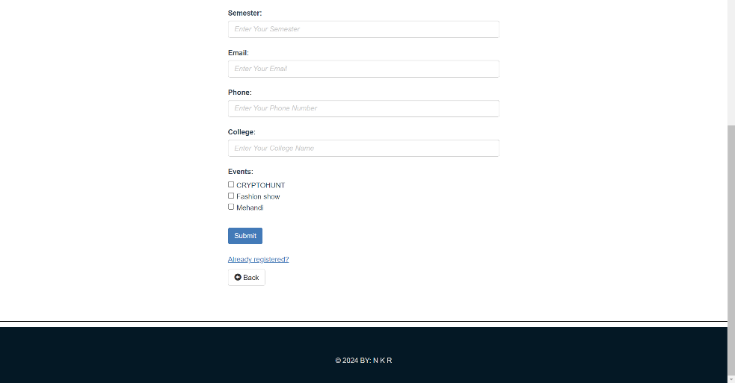

**5.1.3 Contact page**

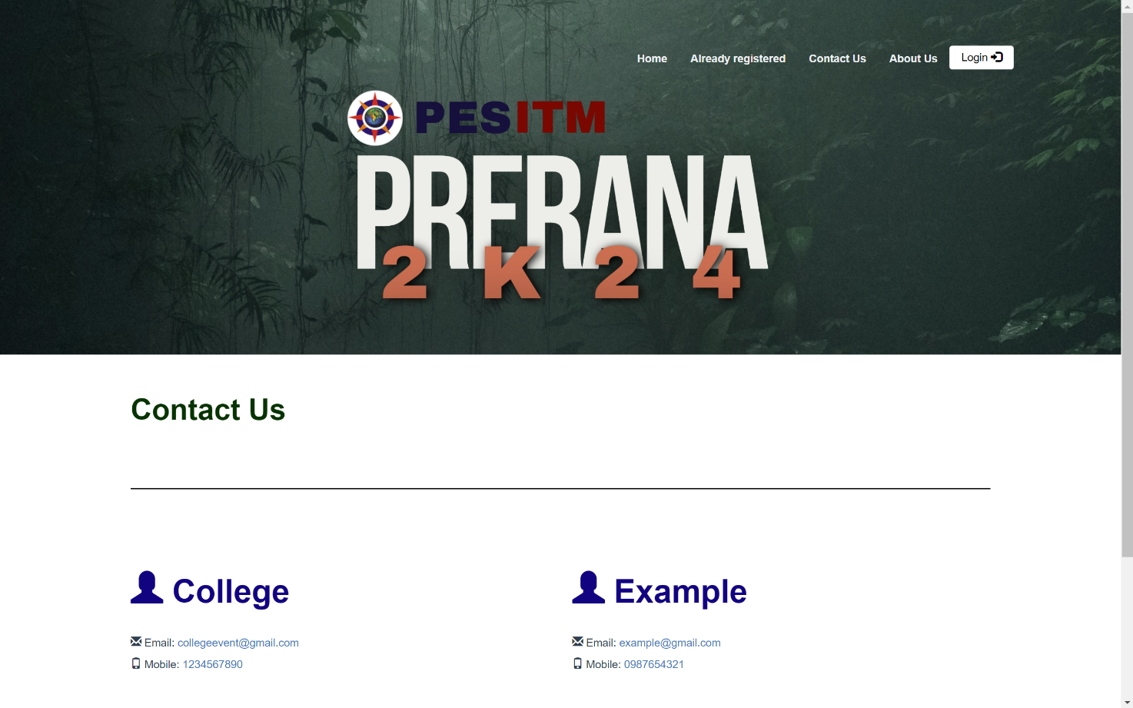

**5.1.4 About page**

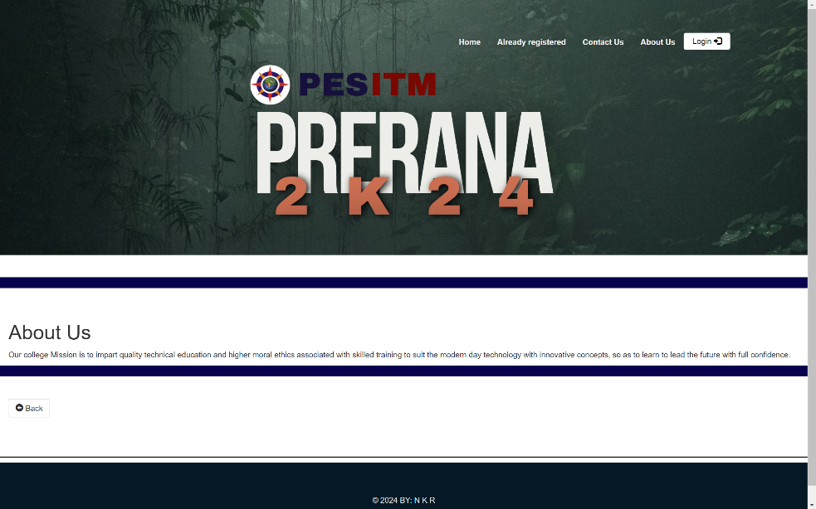

**5.1.5 Already Registered page**

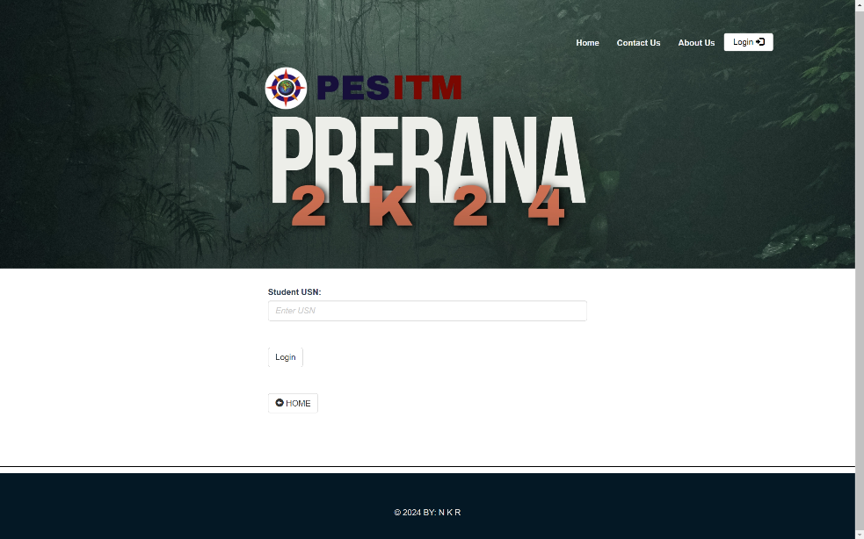

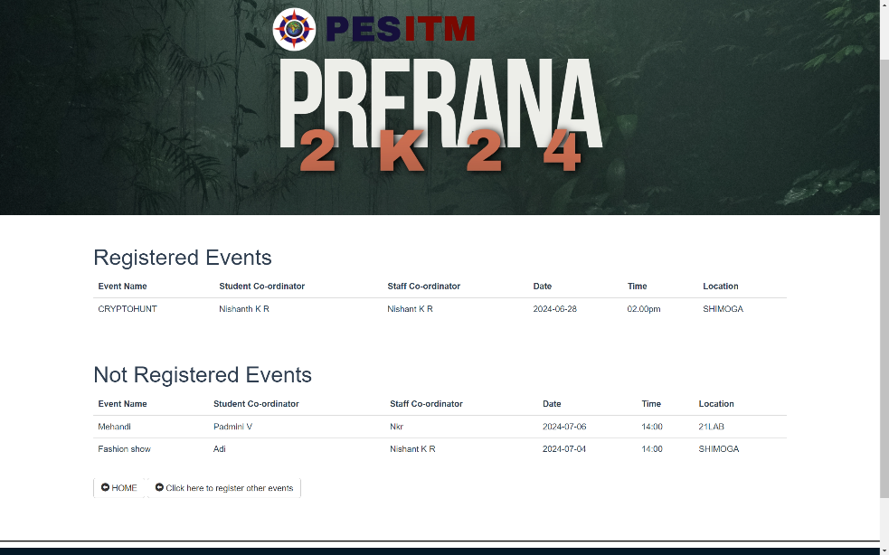

**5.2 Coordinator (Admin) Page**

**5.2.1 Login page**

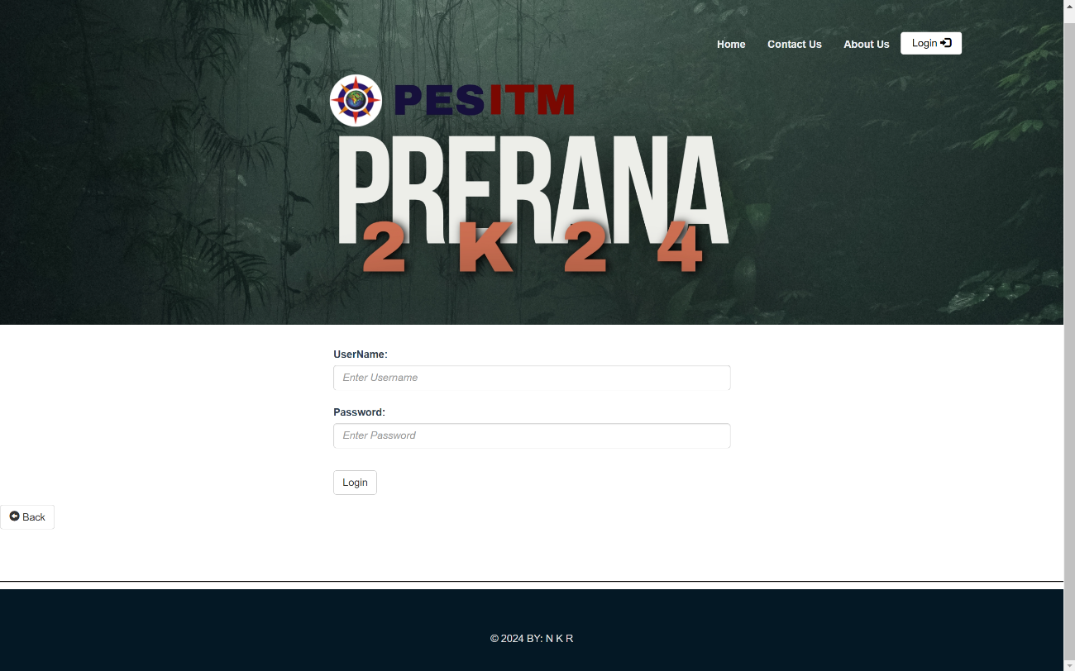

**5.2.2 Event Details page**

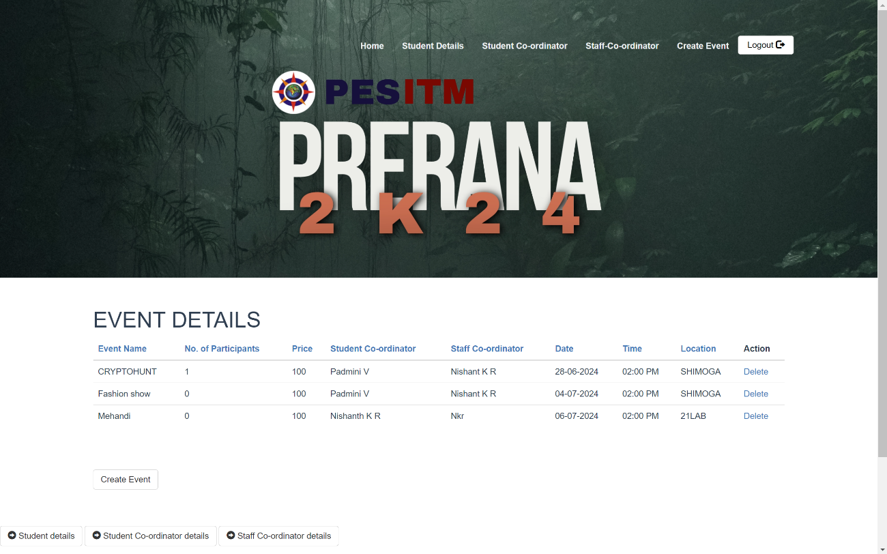

**5.2.3 Create Event page**

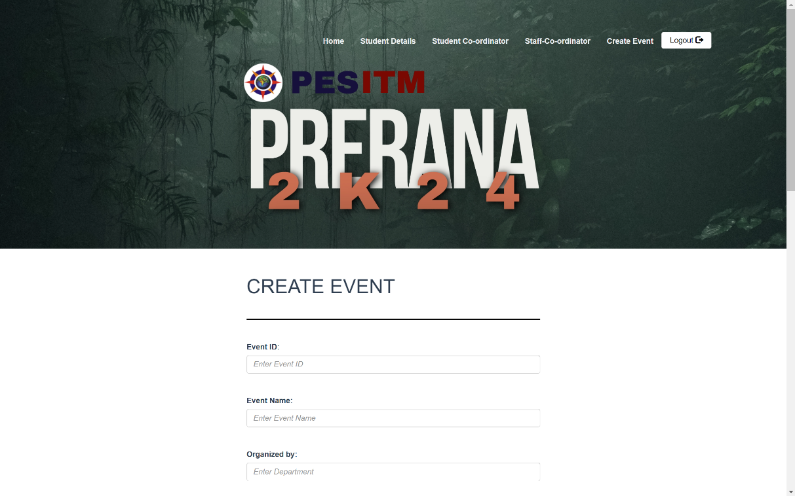

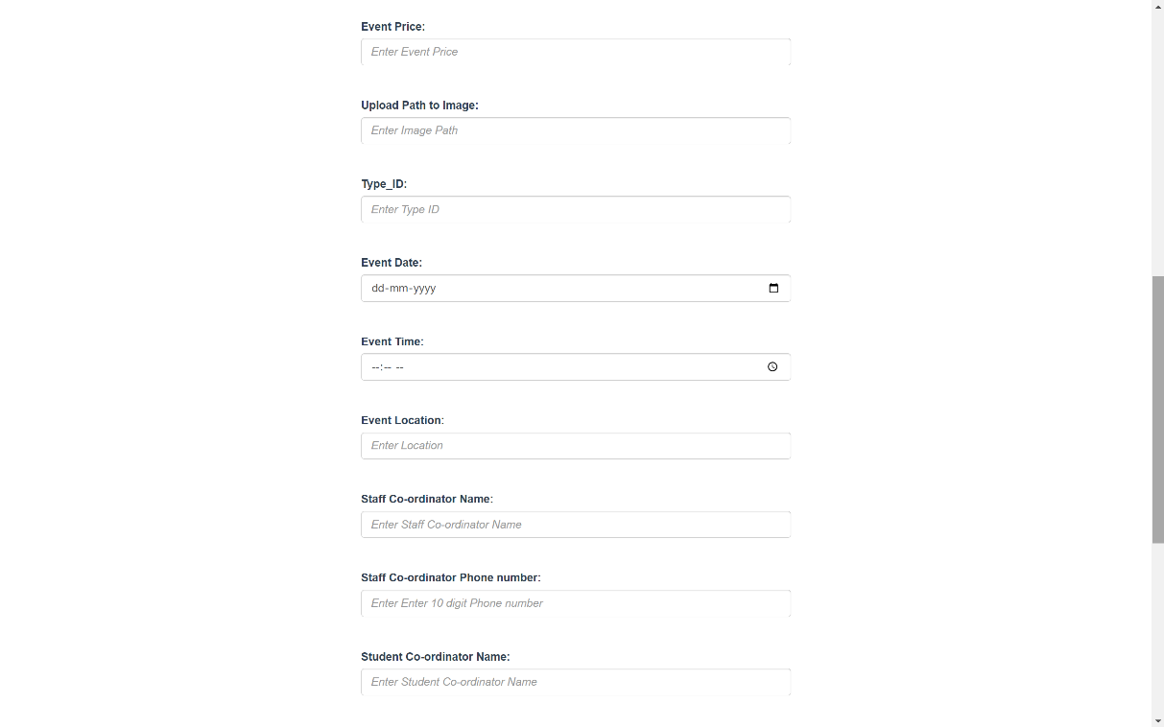

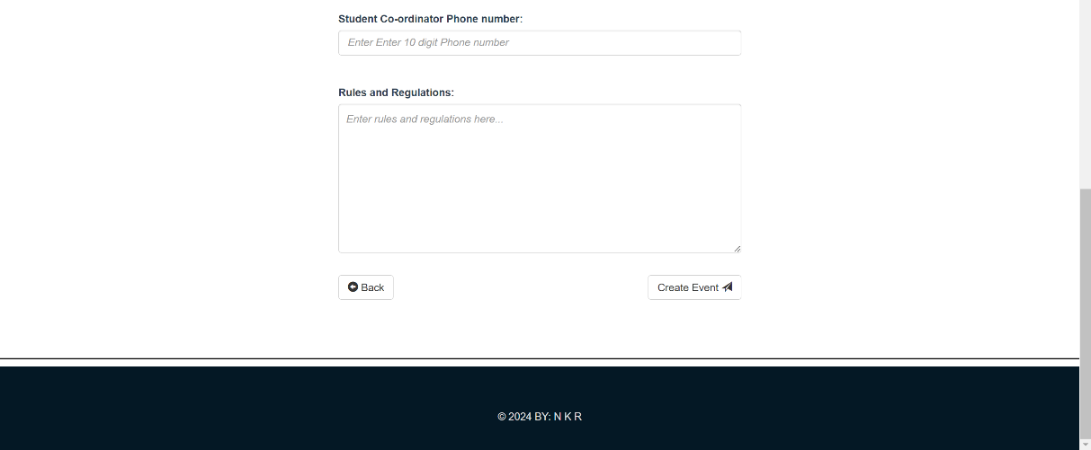

**5.2.4 Participants Details page**

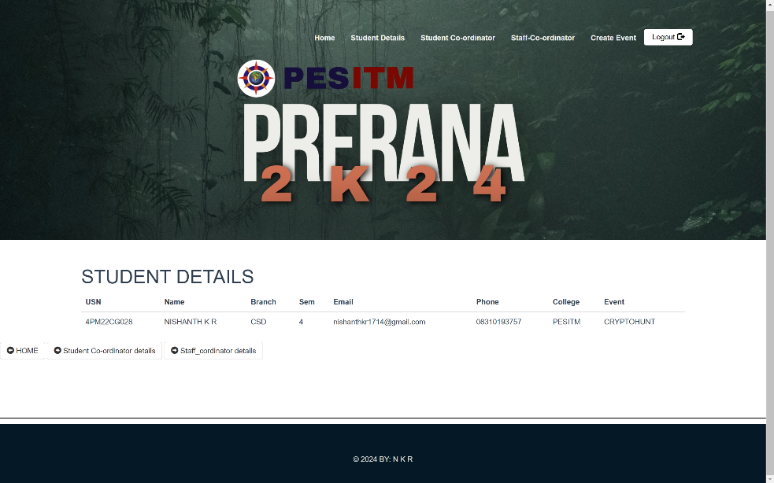

**5.2.5 Student Coordinators Details page**

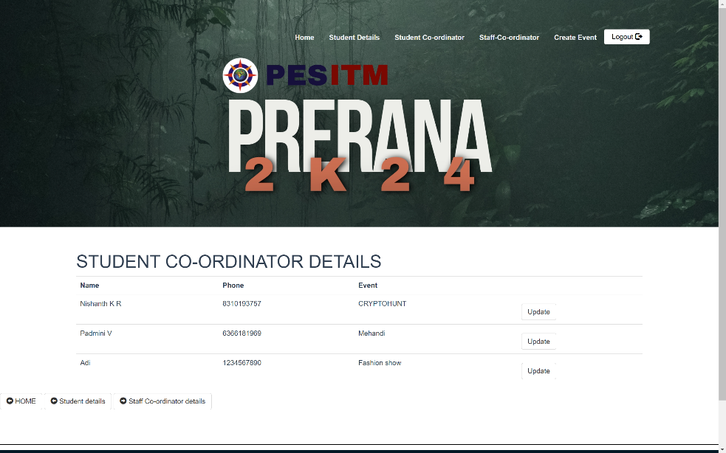

**5.2.6 Staff Coordinators Details page**

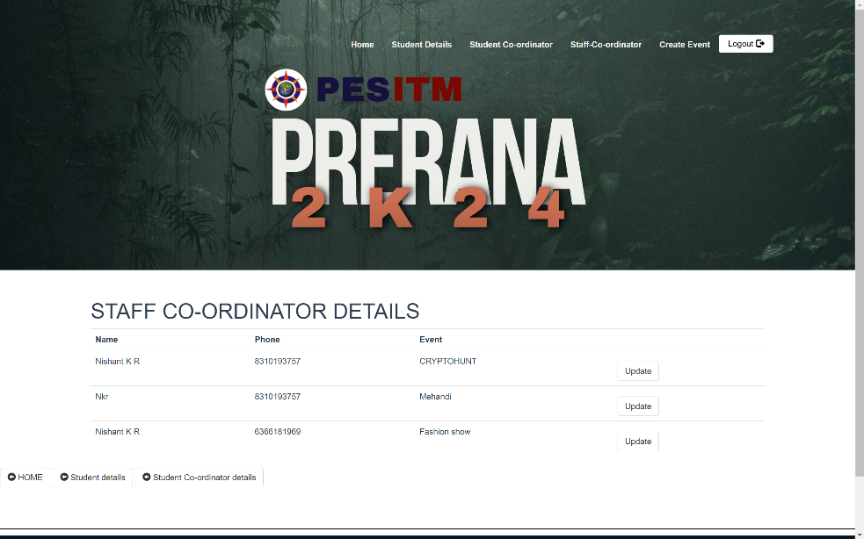

**CHAPTER 6**

**CONCLUSION**

The development and implementation of the College Event Management System represent a pivotal step forward in the realm of educational institution event coordination. This system brings about enhanced efficiency, streamlined processes, and improved participant engagement, all contributing to a more seamless event management experience. Throughout the project lifecycle, from inception to deployment, careful consideration of user needs, meticulous design, and rigorous testing have been integral to ensuring the system's reliability and effectiveness.

In conclusion, the College Event Management System stands as a testament to the transformative power of technology in optimizing event organization within educational settings. Its user-friendly interface, coupled with robust features tailored to administrators, event coordinators, and participants alike, fosters a collaborative and cohesive environment for planning, executing, and evaluating events. By leveraging digital channels and self-service capabilities, the system empowers stakeholders to manage events efficiently from any location, at any time.

Looking ahead, as technology continues to evolve and educational institutions embrace digital transformation, ongoing updates and enhancements will be essential to keep the system aligned with emerging needs and trends. Collaboration between developers, administrators, coordinators, and participants will be crucial in refining and expanding the system's capabilities to meet the dynamic demands of event management in academia.

In essence, the College Event Management System not only enhances operational efficiency but also enriches the overall event experience for participants, fostering a vibrant and engaging campus community. It underscores the commitment to innovation and excellence in educational event management, paving the way for continued advancements and improvements in the future.

**BIBLIOGRAPHY**

1. **Books and Articles:**
   * Silberschatz, A., Korth, H. F., & Sudarshan, S. (2010). *Database System Concepts*. McGraw-Hill.
   * Ullman, J. D., & Widom, J. (2008). *A First Course in Database Systems*. Prentice Hall.
   * McLaughlin, B., Pollice, G., & West, D. (2006). *Head First Object-Oriented Analysis and Design*. O'Reilly Media.
2. **Online Resources:**
   * W3Schools. (n.d.). PHP Tutorial. Retrieved from <https://www.w3schools.com/php/>
   * Mozilla Developer Network (MDN). (n.d.). JavaScript Guide. Retrieved from <https://developer.mozilla.org/en-US/docs/Web/JavaScript/Guide>
   * Bootstrap. (n.d.). Introduction. Retrieved from <https://getbootstrap.com/docs/4.0/getting-started/introduction/>
3. **Software and Tools:**
   * Apache Friends. (n.d.). XAMPP. Retrieved from <https://www.apachefriends.org/index.html>
   * MySQL. (n.d.). MySQL Documentation. Retrieved from <https://dev.mysql.com/doc/>
   * jQuery. (n.d.). jQuery Documentation. Retrieved from <https://jquery.com/>
4. **Research Papers:**
   * Elmarsi, R., & Navathe, S. B. (2015). *Fundamentals of Database Systems*. Addison-Wesley.
   * E. F. Codd. (1970). "A Relational Model of Data for Large Shared Data Banks". *Communications of the ACM*, 13(6): 377-387.
5. **Technical Documentation:**
   * PHP Documentation. (n.d.). Retrieved from <https://www.php.net/docs.php>
   * CSS Tricks. (n.d.). A Complete Guide to Flexbox. Retrieved from <https://css-tricks.com/snippets/css/a-guide-to-flexbox/>
6. **Educational Institutions and Courses:**
   * PES Institute of Technology and Management. (2023). Course Materials for Computer Science and Design. Internal Publications.
   * Coursera. (n.d.). Web Development Specialization. Retrieved from <https://www.coursera.org/specializations/web-design>
7. **Others:**
   * Stack Overflow. (n.d.). Various technical discussions and solutions. Retrieved from <https://stackoverflow.com/>
   * GitHub. (n.d.). Various open-source projects and repositories. Retrieved from <https://github.com/>